Minor Illnesses
and
School Attendance
A Guide For Parents

Introduction
Good school attendance improves your child’s chance of achieving their full potential. Children who attend school regularly are more likely to achieve at school and reach their full potential. Missing school disrupts school routines and learning. The most common reason given for children to miss school is illness, however most of the time childhood ailments can be managed in school. To help avoid unnecessary school absences while promoting child welfare, this leaflet has been produced as a general guide to help parents decide whether your child is well enough to attend school. Please also check your child’s school attendance policy or speak to school directly if you are still unsure.
It is not necessary to ask your GP for a note or letter, especially if your child is off school for less than a week with a minor illness. Schools should authorise absences due to illness unless they have genuine cause for concern about the veracity of an illness.

Is my child well enough to attend school?
Many children experience common ailments from time to time. Most of these do not need a prescription, are rarely serious and do not require time away from school. Often treating your child’s ailment or illness yourself, or with advice and medicines from your pharmacist, is all that is necessary.
Schools may not agree to authorise your child’s absence for minor illnesses and you have a duty to ensure your child is not absent where this can be avoided.

Some common rules about illness absences
If your child is unwell on a school day, you need to follow your school’s attendance policy/absence procedures which is usually available on the school website. Please always contact the school in the morning to let them know the specific reason for absence, as this needs to be logged in the class register.

Longer Term Absence
If there are concerns about your child’s attendance the school may ask you to present evidence to verify the reason for absence, or ask you if they can refer your child to the school nurse.
A letter from parent is needed when:
• A child has any condition requiring hospital or surgical care.
• The child returns to school with a cast or stitches.
• The child needs restricted PE lessons or playtime activities for more than three consecutive days.
If your child has attended the Emergency Department or been admitted to hospital, please follow the recommendations of hospital staff for advice on when your child is able to return to school. If your child is going to be absent long term, then home tuition for medical needs may be offered.

When a parent or sibling is Ill
A parent should make alternate arrangements to get the well child to school. Family illness is not considered a legitimate reason for school absence. Developing good family or parent networks can be helpful. Please discuss any difficulties with the school as they may be able to offer support.

Minor illnesses
Raised temperature (fever)
If your child is shivery or feels hot, they may have a raised temperature. This may be due to a variety of reasons. If your child has a raised temperature (over 38 degrees), they should not be in school. It is important to measure the temperature accurately with a digital thermometer, which you can buy from a supermarket or pharmacy. Please follow the instructions for use carefully. Your child should be able to return to school once they feel and look better.
For further information please visit: www.nhs.uk/conditions/fever-in-children

Rashes
A rash could be one of the first signs of many childhood illnesses, such as chickenpox or measles. The rash or ‘spots’ may cover the entire body or may only appear in one area. If your child has an unexplained rash, please seek medical advice. Do not send a child to school with an unexplained rash that may be infectious, until you have consulted your doctor or they are better. If the rash has been diagnosed as infectious, please see the table in this booklet (page 7) for guidance on whether your child should be attending school.
For further information please visit: www.nhs.uk/conditions/rashes-babies-andchildren

Colds and coughs
Children can attend school with a mild cold and cough. If your child has asthma, remember they may need their reliever inhaler (usually blue) more often and should attend the GP at least once per year to review their asthma medication. They should have a spare inhaler and spacer which they can use when they are at school. Occasionally coughs can be persistent and last for weeks. Children with bad or long-lasting coughs need to see their GP. Once treated, or when the cough is improving and the child is feeling better, they need to return to school.

Toothache/earache
If your child has a toothache for longer than two days, it is recommended that they see a dentist. Ear infections and ear ache are very common, particularly in children. You don’t always need to see a GP for an ear infection as they often get better on their own. If your child has a raised temperature (over 38degrees), they will need to stay off school until this improves. Your child may also need pain relief if they are experiencing an ear ache. If there is no improvement in your child after three days, please seek medical advice from a health professional.
For further information, visit: www.nhs.uk/conditions/earache

Headache
If the only complaint is a slight headache, your child will not usually need to be kept at home. If a headache is persistent and not responding to pain relief, contact your GP.

Tummy ache
If your child complains of mild tummy ache and has no other symptoms, they should go to school. If the tummy ache is associated with vomiting/diarrhoea then your child must stay off school until the symptoms have stopped for two days (see page 7). If your child complains of repeated mild tummy ache, headache or other symptoms and does not want to attend school, this could be due to your child being unhappy at school, experiencing bullying or finding school work difficult. Speak to your child, the teacher or school nurse to discuss this and find ways of dealing with it.

Head lice
Head lice and nits (head lice eggs) are very common in young children. They don’t have anything to do with dirty hair and are usually picked up from head-to-head contact. Your child having head lice does not require them to be absent from school. Head lice and nits can be removed by wet combing. This method should be tried first. You can buy a special fine-toothed comb (detection comb) online or from pharmacies. If this treatment is unsuccessful or your child has persistent episodes of head lice, please visit your pharmacist for further advice. For further information, visit: www.nhs.uk/conditions/head-lice-and- nits 9

Vomiting and diarrhoea
If a child has vomiting or has diarrhoea, keep them off school. You can usually treat your child at home. The most important thing is to have plenty of fluids to avoid dehydration. Your child is most infectious from when the symptoms start until 48 hours after the vomiting or diarrhoea has stopped. Once this is the case, your child can return to school.

General Information
Please remember that early morning ‘aches’ in children often pass, so don’t keep your child at home ‘just in case’ when they could be learning in class. Tell school staff and they will phone you if your child continues to have symptoms or report that they are unwell. Your contact details Please make sure that the contact details the school has are current and up to date. It is important that the school is able to make contact with you during the day if your child is not well enough to stay in school. Please also check your child’s school attendance policy or speak to school directly if you are still unsure.
Washing Hands
Washing your hands properly removes dirt, viruses and bacteria to stop spreading to other people and objects, which can spread illnesses such as food poisoning, flu or diarrhoea. You should wash your hands:
• after using the toilet or changing a nappy
• before and after handling raw foods like meat and vegetables
• before eating or handling food
• after blowing your nose, sneezing or coughing
• before and after treating a cut or wound
• after touching animals, including pets, their food and after cleaning their cages Please Remember cover coughs and sneezes with a tissue, throw the tissue in a bin and wash hands after use.

The following table provides information on common childhood illnesses and the most up to date guidance:

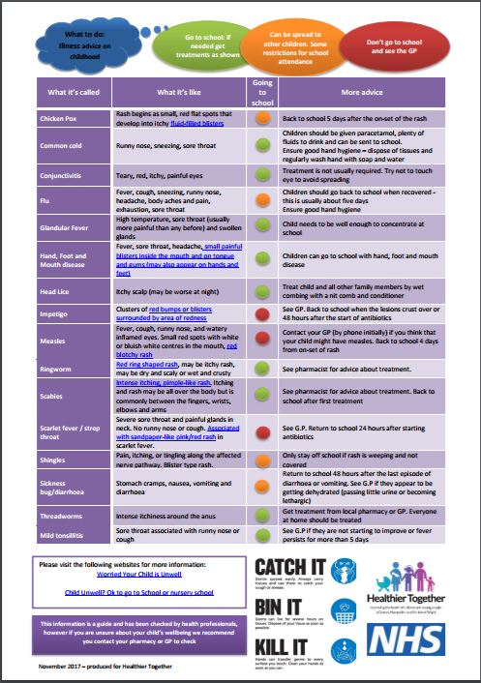
The table provides guidance on some common childhood illnesses:
Useful contact numbers:

Withnell Health Centre 01254 282630
Withnell Pharmacy 01254 830180
Treatment room 01772 644666

GP Out of Hours - www.111.nhs.uk Or Tel: 111

Lancashire & South Cumbria Foundation Trust- School Nursing Services: Email:CFHS.CFHS@lscft.nhs.uk Tel: 01254 585000 option 2

